Mule Anypoint Studio Tutorial – SAP Data Retrieval

This tutorial walks you through how to use Anypoint Studio to build a simple HTTP request-response application for retrieving SAP ERP chart of accounts. After creating and running the example locally, you are able to apply what you learn to create more complex SAP applications.

Prerequisites
This tutorial assumes that you have downloaded and installed Anypoint Studio and SAP JCO .

Goals
This tutorial covers these tasks:
# | Task | Section
1 | Launch Anypoint Studio | Launching Studio
2 | Constructing an Application | Constructing an Application
3 | Test Application | Verifying That Your Application Works
4 | Learn more | Next

Launching Studio
If you launched Studio as part of the installation process, and it is now running, skip the rest of this section and proceed directly to Creating a New Project.
- Navigate to the directory on your local drive in which you installed Studio.
- Double-click the executable file to launch Studio.
  - AnypointStudio.exe in Windows
  - AnypointStudio.app in Mac OS
- When Studio displays the Workspace Launcher dialog, click OK to accept the default workspace.
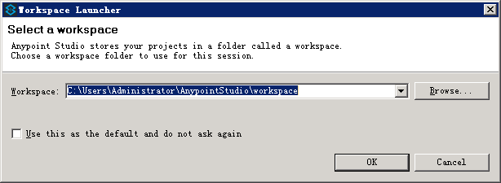
- If this is the first time you have launched Studio, you see a Welcome screen. Click Create a Project to dismiss the screen and jump straight to the New Mule Project wizard.
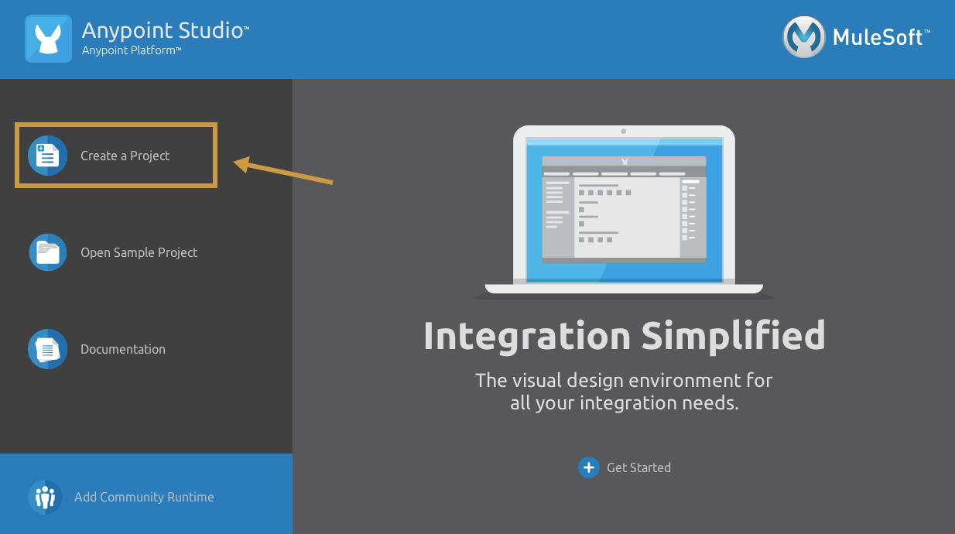

Creating a New Project
- If the New Mule Project screen is not open, click File > New > Mule Project.
Studio opens the New Mule Project wizard.
- Fill in the Project Name field with the value sap-fi-data-retrieval-v1.0.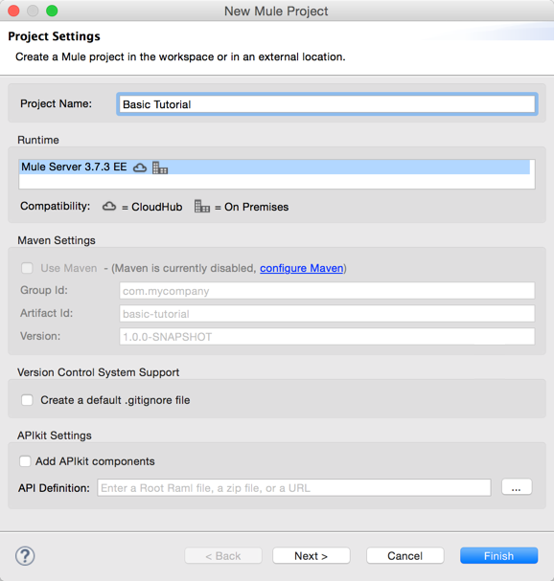
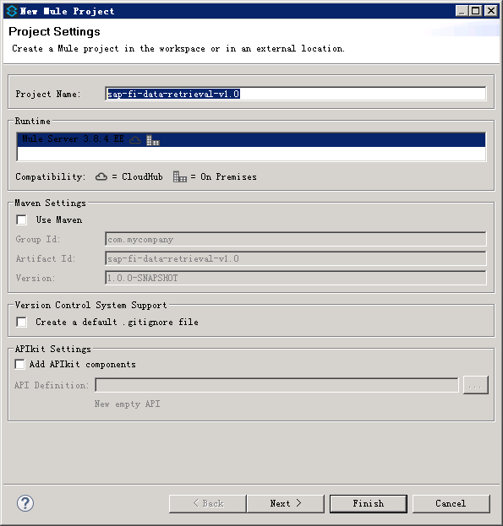
- Click Finish to create the project.
The Studio UI, which has the following main sections, appears:
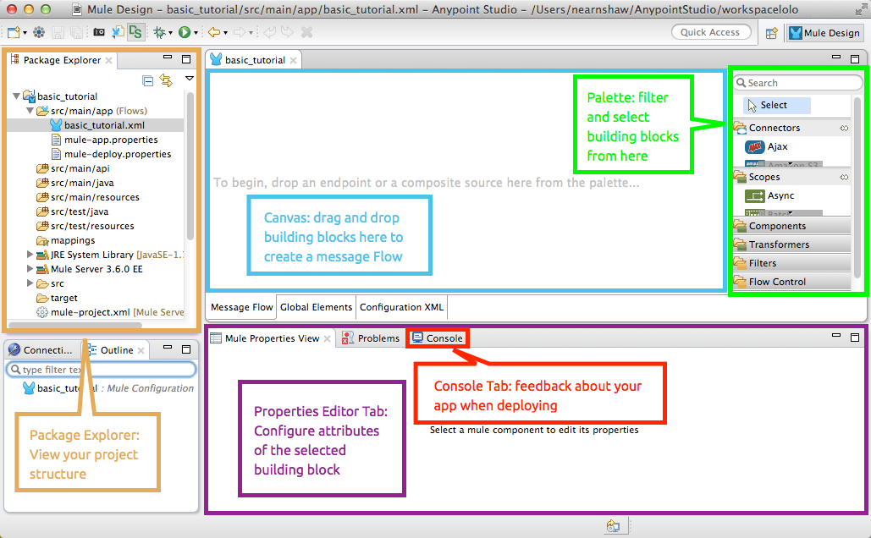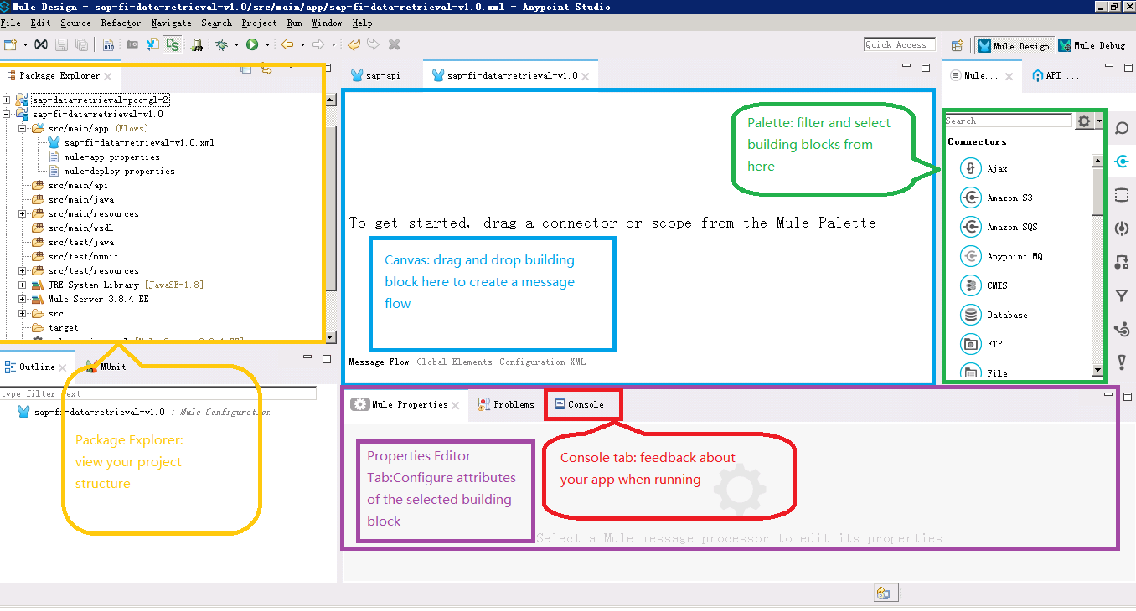
The blue area in the center is the canvas where you build a visual representation of your Mule program by dragging building blocks from the palette outlined in green to the canvas.
At the bottom of the canvas are Message Flow and Configuration XML tabs for alternating between visual and XML editing of the application.
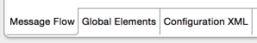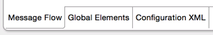
On the Global Elements tab you set properties for configuration elements having global scope, such as the HTTP Listener Configuration and SAP Connection introduced later.

More on the XML File
When you create a Mule Project, Studio creates an XML file in the src/main/app folder, which appears in the Package Explorer. This file stores flow information for the visual editor. Studio derives the file name sap-fi-data-retrieval-v1.0.xml from the project name.
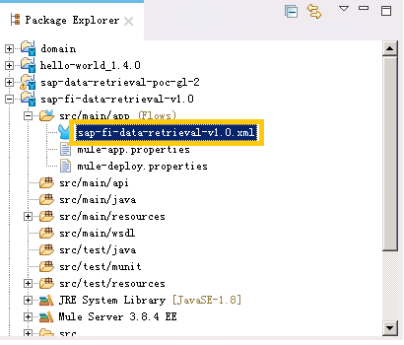
The mule-project.xml file at the bottom of the Package Explorer is the Mule project descriptor file. Open this file to change the project runtime, set or edit environment variables, or edit the project description.

Constructing an Application
In this section of the tutorial, you build an application that displays a message in the browser.
This section uses these building blocks:
HTTP Connector |  | Allows your Mule application to connect to Web resources through the HTTP or HTTPS protocol. Find this in the Connectors section of the palette.
APIkit Router |  | APIkit consists of a set of open source Maven and Mule Studio-based tools that enable developers to be massively productive in creating well-designed REST APIs. Find this in the Flow Control section of the palette.
Flow |  | Mule applications are built around one or more flows. Find this in the Flow Control section of the palette.
SAP Connector |  | Mule runtime supports SAP integration through Anypoint Connector for SAP, an SAP-certified Java connector that leverages the SAP Java Connector (JCo) libraries, thus allowing Mule applications to execute BAPI functions over the RFC protocol. Find this in the connectors section of the palette.
DataWeave |  | The DataWeave Language is a simple, powerful tool used to query and transform data inside of Mule. DataWeave supports a variety of transformations: XML-JSON, JSON-XML.
Tip: Use Studio Search
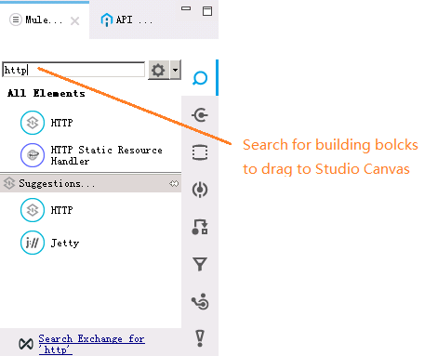

- Search for http in the palette and drag the HTTP connector to the canvas. This action creates the flow named sap-fi-data-retrieval-v1.0Flow.
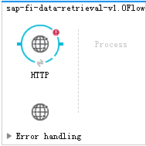
- Search for APIkit and drag the APIKit Router to the Process section of the flow.
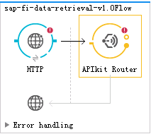
- Select the HTTP connector in the flow. In Basic Settings in the properties editor, change the Path to api/* (asterisk) to allow any path start with /api in the browser. For example, with the api/* setting in place, you can use a browser address like 0.0.0.0:8081/api/accounts path. You need this flexibility later when you add new functions to application.
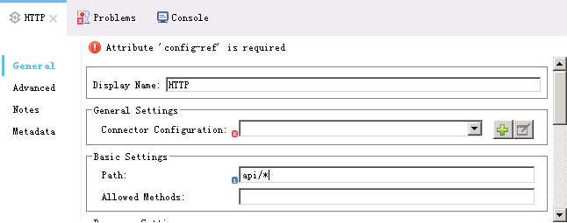
- In General Settings, click the green plus sign to the right of Connector Configuration:
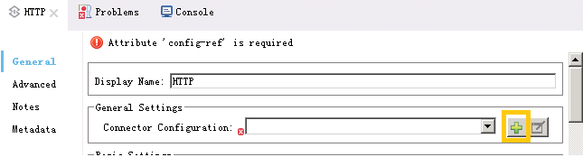
The Global Element Properties dialog appears:
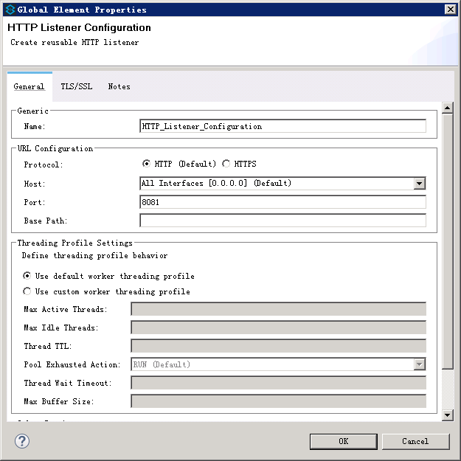
- Click OK to accept the defaults: Host 0.0.0.0 and Port 8081.
Later, you use the host IP address and port number 0.0.0.0:8081 in a browser to view the application response.
- Create a RAML file for API define: in Project Exporler , right-click at src/main/resource , select RAML API Definition :
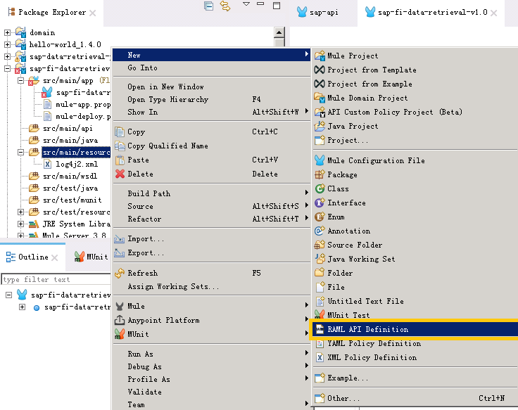
- Enter file name SAP API and select folder main/src/resources
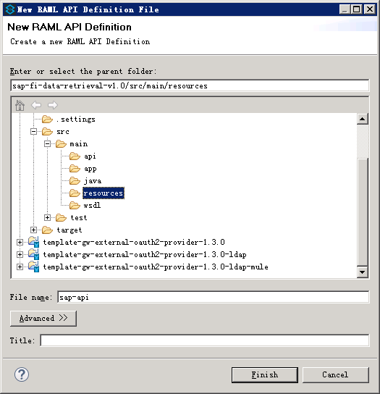

- Enter file content and save.
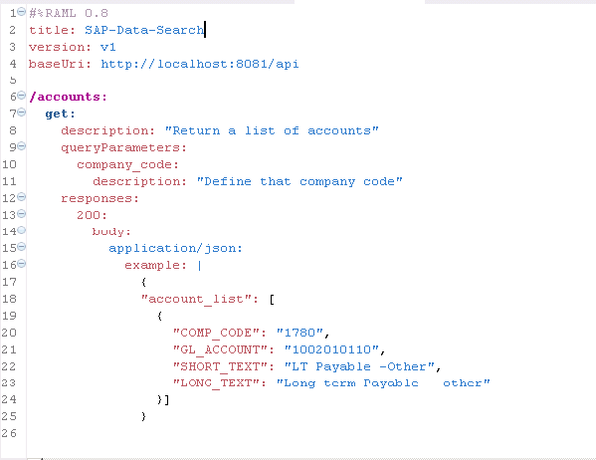

#%RAML 0.8
title: SAP-Data-Search
version: v1
baseUri: http://localhost:8081/api

/accounts:
get:
description: "Return a list of accounts"
queryParameters:
company_code:
description: "Define that company code"
responses:
200:
body:
application/json:
example: |
{
"account_list": [
{
"COMP_CODE": "1780",
"GL_ACCOUNT": "1002010110",
"SHORT_TEXT": "LT Payable -Other",
"LONG_TEXT": "Long-term Payable - other"
}]
}

- Click the APIKit Rouer to set its properties, and click the green plus sign to the right of Router Configuration:
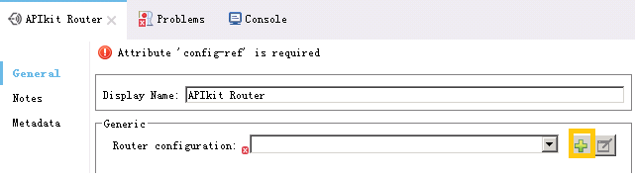
- Select RAML file just created, and click the green plus sign to the under of Mappings:
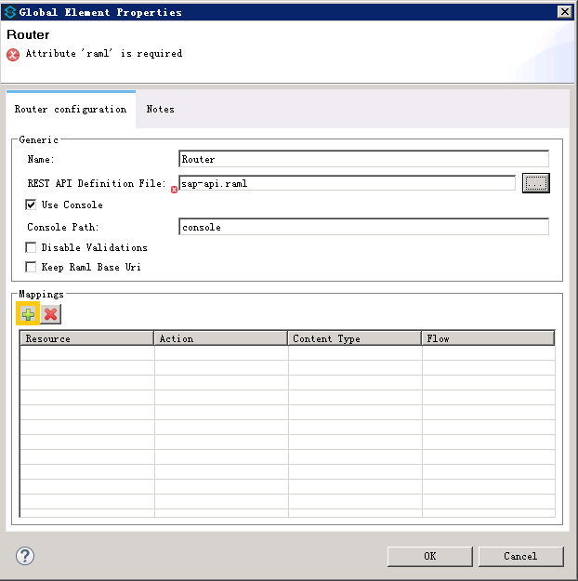

- Add new map:
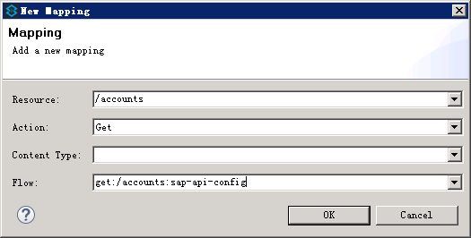
In Flow input box , enter get:/accounts:sap-api-config which refer to the flow will be created in next steps.

- Search for Flow in the palette and drag the Flow to the canvas. This action creates the flow named sap-fi-data-retrieval-v1.0Flow1.
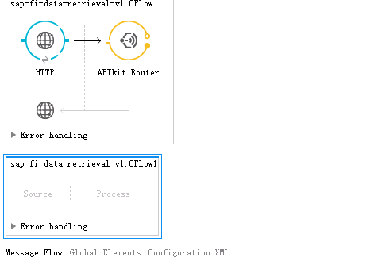
- Click the new flow, change flow name to get:/accounts:sap-api-config:
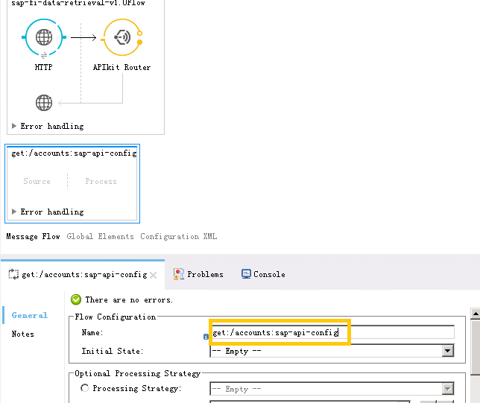

- Search for DW in the palette and drag the DW Transform to the Process section of the flow get:/accounts:sap-api-config.
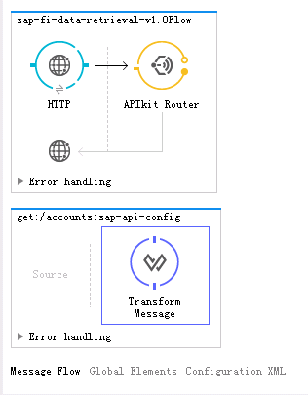
- Search for SAP in the palette and drag the SAP Connector to the Process section of the flow get:/accounts:sap-api-config after DW transform.
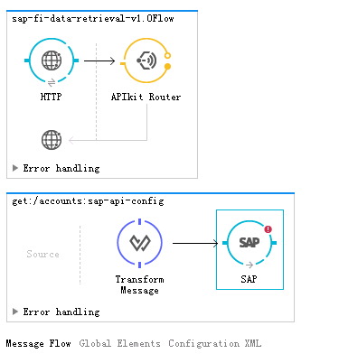
- Search for DW in the palette and drag the DW Transform again to the Process section of the flow get:/accounts:sap-api-config after SAP Connector.
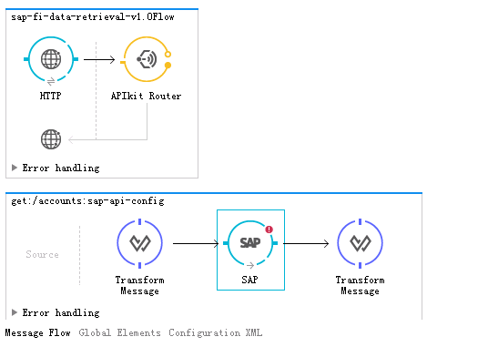
- Click the first DW transform to set its properties, and enter text in to the right of Output Payload:
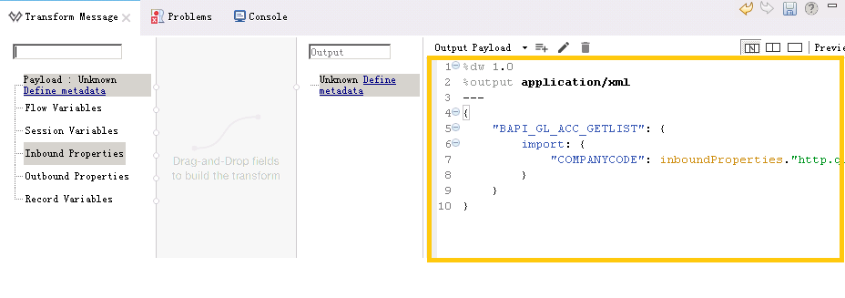
%dw 1.0
%output application/xml
---
{
"BAPI_GL_ACC_GETLIST": {
import: {
"COMPANYCODE": inboundProperties."http.query.params"."company_code"
}
}
}

- This step setup a SAP connection. Click Global Elements, then click Create button.
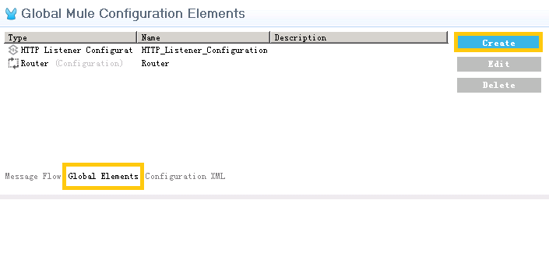
- Select Connector Configuration – SAP
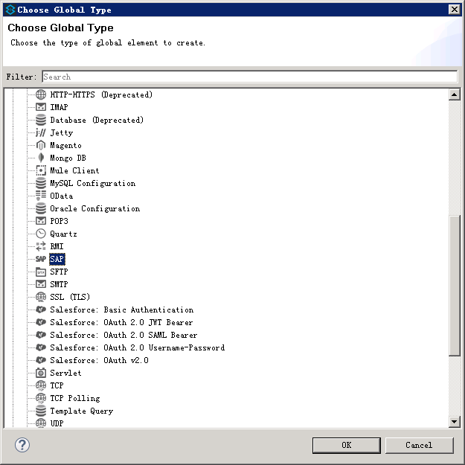

- On the popup dialog box:
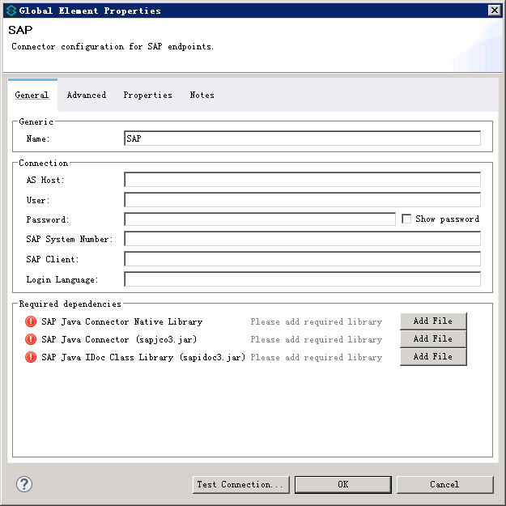

Enter your SAP connection information, and select JCO libs which your download from SAP support site.
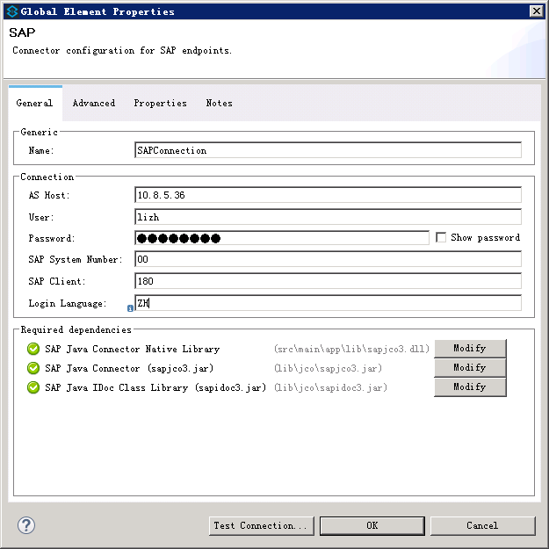
Your can click Test Connection button, if everything is OK, your will see:
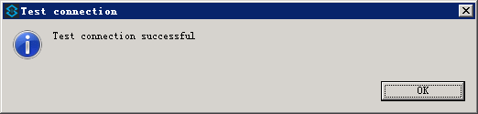

- Click Message Flow to return Canvas:
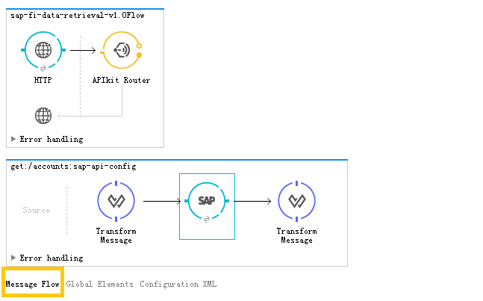

- Click the SAP Connector to set its properties.
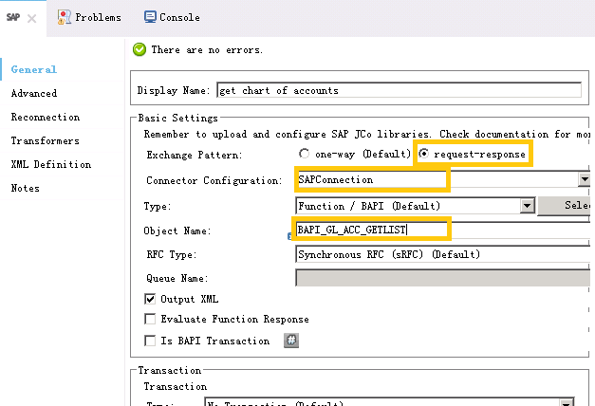
Change Display Name: to get chart of accounts . Select Exchange Pattern: to request-response. Select Connector Configuration: SAPConnection which your just created. Enter SAP BAPI function name BAPI_GL_ACC_GETLIST in Object Name:. Click OK to finish the dialog.
- Click the last DW transform to set its properties, and enter text in to the right of Output Payload:
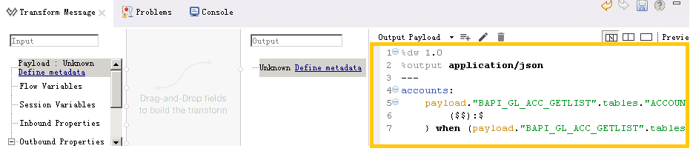
%dw 1.0
%output application/json
---
accounts:
payload."BAPI_GL_ACC_GETLIST".tables."ACCOUNT_LIST".*row map {
($$):$
} when (payload."BAPI_GL_ACC_GETLIST".tables.ACCOUNT_LIST != "") otherwise { message:"No data found."}

With just a few clicks, you have created an application. The finished Message Flow like this:
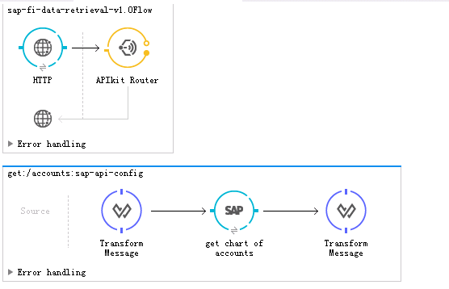
The source code of application like this:
<?xml version="1.0" encoding="UTF-8"?>

<mule xmlns:dw="http://www.mulesoft.org/schema/mule/ee/dw" xmlns:apikit="http://www.mulesoft.org/schema/mule/apikit" xmlns:sap="http://www.mulesoft.org/schema/mule/sap" xmlns:tracking="http://www.mulesoft.org/schema/mule/ee/tracking" xmlns:http="http://www.mulesoft.org/schema/mule/http" xmlns="http://www.mulesoft.org/schema/mule/core" xmlns:doc="http://www.mulesoft.org/schema/mule/documentation"
xmlns:spring="http://www.springframework.org/schema/beans"
xmlns:xsi="http://www.w3.org/2001/XMLSchema-instance"
xsi:schemaLocation="http://www.springframework.org/schema/beans http://www.springframework.org/schema/beans/spring-beans-current.xsd
http://www.mulesoft.org/schema/mule/core http://www.mulesoft.org/schema/mule/core/current/mule.xsd
http://www.mulesoft.org/schema/mule/http http://www.mulesoft.org/schema/mule/http/current/mule-http.xsd
http://www.mulesoft.org/schema/mule/apikit http://www.mulesoft.org/schema/mule/apikit/current/mule-apikit.xsd
http://www.mulesoft.org/schema/mule/ee/tracking http://www.mulesoft.org/schema/mule/ee/tracking/current/mule-tracking-ee.xsd
http://www.mulesoft.org/schema/mule/sap http://www.mulesoft.org/schema/mule/sap/current/mule-sap.xsd
http://www.mulesoft.org/schema/mule/ee/dw http://www.mulesoft.org/schema/mule/ee/dw/current/dw.xsd">
<http:listener-config name="HTTP_Listener_Configuration" host="0.0.0.0" port="8081" doc:name="HTTP Listener Configuration"/>
<apikit:config name="Router" raml="sap-api.raml" consoleEnabled="true" consolePath="console" keepRamlBaseUri="false" doc:name="Router">
<apikit:flow-mapping resource="/accounts" action="get" flow-ref="get:/accounts:sap-api-config"/>
</apikit:config>
<sap:connector name="SAPConnection" jcoAsHost="10.8.5.36" jcoUser="lizh" jcoPasswd="XXXXXX" jcoSysnr="00" jcoClient="180" jcoLang="ZH" validateConnections="true" doc:name="SAP"/>
<flow name="sap-fi-data-retrieval-v1.0Flow">
<http:listener config-ref="HTTP_Listener_Configuration" path="api/*" doc:name="HTTP"/>
<apikit:router config-ref="Router" doc:name="APIkit Router"/>
</flow>
<flow name="get:/accounts:sap-api-config">
<dw:transform-message doc:name="Transform Message">
<dw:set-payload><![CDATA[%dw 1.0
%output application/xml
---
{
"BAPI_GL_ACC_GETLIST": {
import: {
"COMPANYCODE": inboundProperties."http.query.params"."company_code"
}
}
}]]></dw:set-payload>
</dw:transform-message>
<sap:outbound-endpoint outputXml="true" responseTimeout="10000" doc:name="get chart of accounts" exchange-pattern="request-response" connector-ref="SAPConnection" functionName="BAPI_GL_ACC_GETLIST" type="function"/>
<dw:transform-message doc:name="Transform Message">
<dw:set-payload><![CDATA[%dw 1.0
%output application/json
---
accounts:
payload."BAPI_GL_ACC_GETLIST".tables."ACCOUNT_LIST".*row map {
($$):$
} when (payload."BAPI_GL_ACC_GETLIST".tables.ACCOUNT_LIST != "") otherwise { message:"No data found."} ]]></dw:set-payload>
</dw:transform-message>
</flow>
</mule>

Verifying That Your Application Works
To test the application:
- Click the top project name in Package Explorer and click Run > Run As > Mule Application:
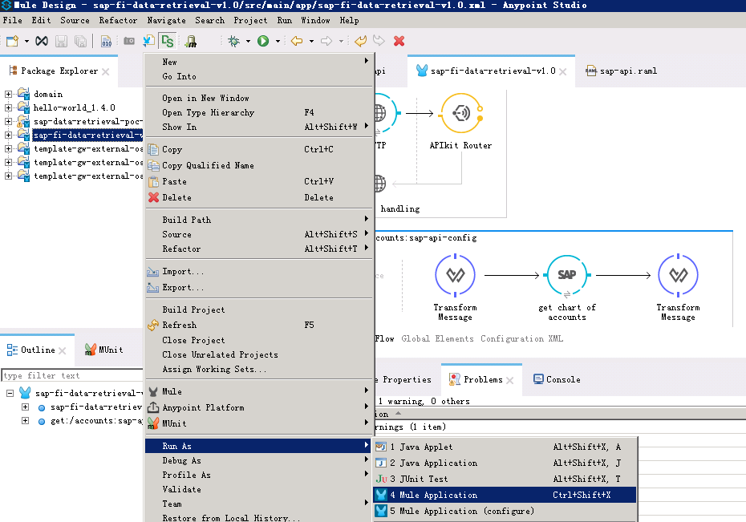
Click OK to save and launch the application.
The console lists output that looks something like this:
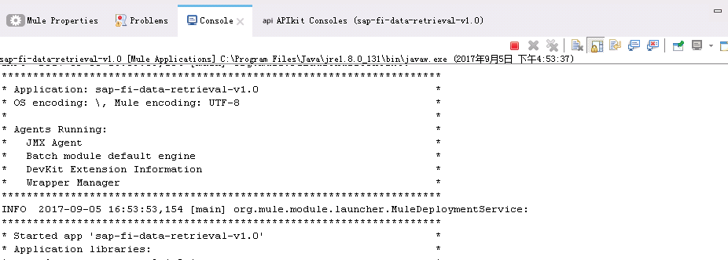
- Using APIkit Consoles , you can test the application:
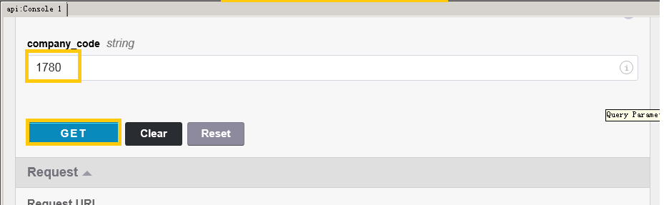
Enter a company code, then click GET. The application will return chart of accounts of the company code.
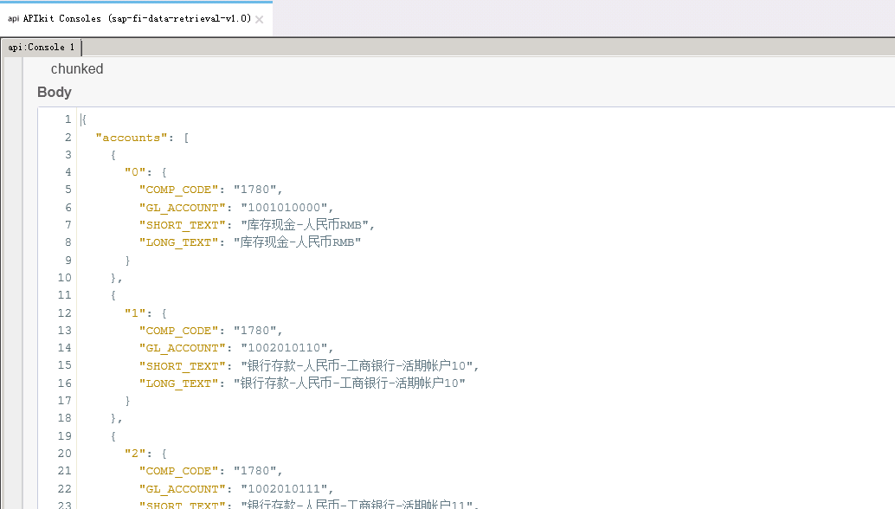

- You can also using curl or web browser to test the application.
curl –i “http://127.0.0.1:8081/api/accounts?company_code=1780”

Next
The following topics help you augment your knowledge of Studio:
- Transforming data: DataWeave Tutorial
- Get a deeper explanation about the Mule message and anatomy of a Mule flow in Mule Concepts.

